Lab 1 - Bayesian Statistics

Daniel Carpenter

January 2022

Table of Contents

## 0.1 Helpful R Markdown Cheat sheets and Links

* [Lesson 1 for R Markdown](http://rmarkdown.rstudio.com/lesson-1.html)
* [R Markdown Cheat sheet (v2.0)](https://github.com/rstudio/cheatsheets/blob/main/rmarkdown-2.0.pdf)
* [R Markdown Reference Guide](https://www.rstudio.com/wp-content/uploads/2015/03/rmarkdown-reference.pdf?_ga=2.209992917.1171562397.1642623613-1554842467.1639495227)
* [Other R Markdown Cheat sheets](https://rmarkdown.rstudio.com/lesson-15.html)

## 0.2 Examples of LaTex Formulae with R

* [Note helpful LaTex repository here](https://www.overleaf.com/learn/latex/Learn_LaTeX_in_30_minutes#!#Adding_math_to_LaTeX)

#### 0.2.0.1 Example a:

$$(x+a)^{n}=\sum_{k=0}^{n}{\left(\begin{matrix}n \\ k\end{matrix}\right)}x^{k}a^{n−k}$$

#### 0.2.0.2 Example b:

$$
(1 + x)^n = 1
+ \frac{nx}{1!} + \frac{n(n-1)x^2}{n!} + \dotsm
$$

#### 0.2.0.3 Example c:

$$f(x)=a_{0}+\sum_{n=1}^{∞}{(}a_{n}\text{cos}\frac{nπx}{L}+b_{n}\text{sin}\frac{nπx}{L})$$

#### 0.2.0.4 Example d:

$$
e^x = 1
+ \frac{x}{1!}
+ \frac{x^2}{2!}
+ \frac{x^3}{3!}
+ \dotsm, -\infty < x < \infty
$$

## 0.3 Histogram of $μ$

library(rstan)

## Loading required package: StanHeaders

## Loading required package: ggplot2

## rstan (Version 2.21.3, GitRev: 2e1f913d3ca3)

## For execution on a local, multicore CPU with excess RAM we recommend calling  
## options(mc.cores = parallel::detectCores()).  
## To avoid recompilation of unchanged Stan programs, we recommend calling  
## rstan_options(auto_write = TRUE)

## Do not specify '-march=native' in 'LOCAL_CPPFLAGS' or a Makevars file

library(Intro2R)  
  
# Suggested to do this with multiple cores  
options(mc.cores = parallel::detectCores())  
rstan_options(auto_write = TRUE)  
  
# Read in the ddt csv file  
ddt <- read.csv("Input_Files/DDT.csv")  
  
# Create model using rstan  
basic_data <- list(y=ddt$LENGTH, N=length(ddt$LENGTH))  
fit <- stan(file = "Input_Files/basic.stan",  
 model_name = "basic",  
 data = basic_data,  
 chains = 3,  
 warmup = 1000,  
 cores = 3,  
 iter = 5000,  
 pars = c("mu")  
 )  
  
# ---  
  
library(ggplot2)  
library(rstanarm)

## Loading required package: Rcpp

## This is rstanarm version 2.21.1

## - See https://mc-stan.org/rstanarm/articles/priors for changes to default priors!

## - Default priors may change, so it's safest to specify priors, even if equivalent to the defaults.

## - For execution on a local, multicore CPU with excess RAM we recommend calling

## options(mc.cores = parallel::detectCores())

##   
## Attaching package: 'rstanarm'

## The following object is masked from 'package:rstan':  
##   
## loo

library(bayesplot)

## This is bayesplot version 1.8.1

## - Online documentation and vignettes at mc-stan.org/bayesplot

## - bayesplot theme set to bayesplot::theme_default()

## * Does _not_ affect other ggplot2 plots

## * See ?bayesplot_theme_set for details on theme setting

# Create a blue histogram of mu  
color_scheme_set("blue")  
mcmc_hist(fit,pars = c("mu"))

## `stat_bin()` using `bins = 30`. Pick better value with `binwidth`.

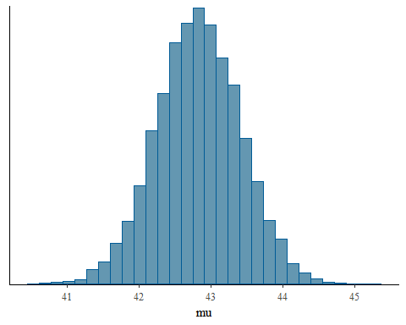

## 0.4 Assessment for Bayesian Statistics

|  |  |
| --- | --- |
| Group | Weight |
| Assignments | 40% |
| Midterm Exam | 10% |
| Lab Exercises | 10% |
| Chapter Quizzes | 10% |
| Final Exam | 30% |
| **Total** | **100%** |